**<English Language Learning App>**

**Design Document**

**Version 1.0**



**Group ID:** S25PROJECTBE85A

**Supervisor Name:** Haseeb Akmal

**Revision History**

|  |  |  |  |
| --- | --- | --- | --- |
| **Date (dd/mm/yyyy)** | **Version** | **Description** | **Author** |
| 7/12/2025 | 1.0 | This design document provides detailed descriptions and diagrams, including ERD, sequence diagrams, architecture design, class diagrams, database design, interface design, and test cases, to serve as a comprehensive blueprint for developing the English language learning app. | BC220202124 |
|  |  |  |  |
|  |  |  |  |
|  |  |  |  |

**Table of Contents**

Introduction of Design Document:- 4

Entity Relationship Diagram (ERD) 9

Sequence Diagrams:- 10

Architecture Design Diagram:- 29

Class Diagram:- 30

Database Design 31

Interface Diagrams:- 32

1. Application Home Page UI:- 32

32

2. Registration Page UI:- 33

3. Login Page UI:- 34

4. User Panel UI:- 35

35

Test Cases:- 38

Test Case - TC-01 - Register/Login (via email or social accounts) 38

Test Case - TC-02 - Manage User Roles (Admin, Teacher, Student) 38

Test Case - TC-03 - Manage Profile (update personal details, password) 38

Test Case - TC-04 - Access Learning Content (browse lessons by level and category) 39

Test Case - TC-05 - Manage Learning Content (create, update, delete content with multimedia) 39

Test Case - TC-06 - Attempt Exercises (grammar, vocabulary, speaking, writing, listening) 39

Test Case - TC-07 - Submit Writing Tasks (get automated grammar/spell feedback) 40

Test Case - TC-08 - Perform Speaking Practice (speech scoring & dialogue simulation) 40

Test Case - TC-09 - Attempt Listening Tasks (with video/audio and follow-up questions) 40

Test Case - TC-10 - Track Progress (view dashboard, skill stats, time spent) 41

Test Case - TC-11 - Generate Reports (view weaknesses, suggestions) 41

Test Case - TC-12 - Earn Certificates (for completing lessons/courses) 41

Test Case - TC-13 - Participate in Gamification (earn points, badges, unlock milestones) 42

Test Case - TC-14 - View Leaderboards (track performance against others) 42

Test Case - TC-15 - Join Live Sessions (video call with teacher or partner) 42

Test Case - TC-16 - Post & Reply in Discussion Forums (grammar, topic-based) 43

Test Case - TC-17 - Peer-to-Peer Messaging (practice with other learners) 43

Test Case - TC-18 - Manage Users and Analytics (Admin functions) 43

Test Case - TC-19 - Logout 43

TASK#1

# Introduction of Design Document:-

This design document outlines the detailed design and architecture of the English language learning application. It includes essential diagrams and descriptions that provide a comprehensive understanding of the system's structure and behavior. The primary purpose of this document is to serve as a blueprint for the development team, ensuring that all aspects of the system are well-documented and clearly defined.

1. **Entity Relationship Diagram (ERD)**

* **Entities**: Represent objects or concepts, such as products, orders and reports that have data stored about them.
* **Relationships:** Illustrate how entities are connected
* **Attributes:**  Characteristics or properties of entities, such as User_id for Users or

This diagram provides a visual representation of the data model, illustrating the relationships between different entities within the system. This diagram is crucial for understanding how data is structured and interconnected.

1. **Sequence Diagrams:**

* **Objects:** Instances of classes that interact in the system.
* **Messages:** Communications between objects, shown as arrows.
* **Lifelines:** Represent the existence of an object over time.
* **Activation:** Represented by a thin rectangle or a tall, thin box, this shows when a participant is actively performing an action or operation.
* **Deactivation:** Represented by a small circle or a short, thin rectangle, this shows when a participant's action or operation is complete.
* **Conditions:** Represented by a diamond or a rectangle with a decision icon, these show the conditions or logic that govern the interactions.
* **Alternative paths:** Represented by a diamond or a rectangle with multiple outgoing arrows, these show alternative scenarios or branches.

Sequence diagrams are provided for each use case, detailing the interactions between objects over time. These diagrams help in visualizing the flow of tasks within the system and are essential for understanding the dynamic behavior of the system.

1. **Architecture Design Diagram:**

* **Layers:** Different levels of the system, such as presentation, business logic, and data access layers.
* **Components:** Functional units within each layer, like User Interface, and Database.
* **Interactions:** How layers and components communicate with each other.

The architecture design diagram presents a tiered architecture of the system, highlighting the different layers and their interactions. This section is important for understanding the overall structure and deployment of the system.

1. **Class Diagram:**

* **Classes:** Blueprints for objects, defining attributes and methods, like User, Admin.
* **Relationships:** Connections between classes, such as inheritance (Admin inherits from User), association, aggregation, and composition.
* **Attributes and Methods:** Characteristics and behaviors defined within each class. The class diagram provides a static view of the system, showing the system classes, their attributes, methods, and relationships. This diagram is fundamental for object-oriented design and development.
* **Inheritance:** Represented by an arrow pointing from a subclass to a super class, this shows the inheritance relationship between classes.
* **Composition:** Represented by a filled diamond at the end of a line connecting classes, this shows the whole-part relationship between classes.
* **Association:** Represented by a line connecting classes, this shows the relationship between classes, such as a student enrolling in a course.
* **Multiplicity:** Represented by numbers or symbols at the ends of a line connecting classes, this shows the cardinality of the relationship, such as one-to-one or many-to-many.
* **Dependencies:** Represented by a dashed arrow pointing from a dependent class to an independent class, this shows the dependency relationship between classes.
* **Interfaces:** Represented by a circle or a rectangle with a name, these define a contract or a set of operations that a class must implement.

1. %3CmxGraphModel%3E%3Croot%3E%3CmxCell%20id%3D%220%22%2F%3E%3CmxCell%20id%3D%221%22%20parent%3D%220%22%2F%3E%3CUserObject%20label%3D%22%22%20tags%3D%22Background%22%20id%3D%222%22%3E%3CmxCell%20style%3D%22vsdxID%3D1%3BfillColor%3Dnone%3BgradientColor%3Dnone%3BstrokeColor%3Dnone%3Bpoints%3D%5B%5B1%2C0.5%2C0%5D%2C%5B0.5%2C0.5%2C0%5D%2C%5B0.5%2C0%2C0%5D%5D%3BlabelBackgroundColor%3Dnone%3Brounded%3D0%3Bhtml%3D1%3BwhiteSpace%3Dwrap%3B%22%20vertex%3D%221%22%20parent%3D%221%22%3E%3CmxGeometry%20x%3D%22838%22%20y%3D%2234%22%20width%3D%22254%22%20height%3D%22401%22%20as%3D%22geometry%22%2F%3E%3C%2FmxCell%3E%3C%2FUserObject%3E%3CmxCell%20id%3D%223%22%20style%3D%22vsdxID%3D2%3BfillColor%3D%23ffffff%3BgradientColor%3Dnone%3Bshape%3Dstencil(rZBLDoAgDERP0z3SI%2Fi5B4kojQgE8Xd7IY3RuHY303lt0gGsF6OCBimWFP2kd%2BqTAWxASnJGR0pZAbaA9eCjHqNfXc8%2BqEIWNfutXDh4T5QNKU52lWDfMWrJvdA7%2FB%2F%2BC83i%2BXMga7mmd%2F7tJY%2B4U2wv)%3BstrokeColor%3D%23ffffff%3Bpoints%3D%5B%5B0%2C0.5%2C0%5D%2C%5B1%2C0.5%2C0%5D%2C%5B0.5%2C1%2C0%5D%2C%5B0.5%2C0%2C0%5D%5D%3BlabelBackgroundColor%3Dnone%3Brounded%3D0%3Bhtml%3D1%3BwhiteSpace%3Dwrap%3B%22%20vertex%3D%221%22%20parent%3D%222%22%3E%3CmxGeometry%20width%3D%22254%22%20height%3D%221%22%20as%3D%22geometry%22%2F%3E%3C%2FmxCell%3E%3CmxCell%20id%3D%224%22%20style%3D%22vsdxID%3D3%3BfillColor%3D%23d8d8d8%3BgradientColor%3Dnone%3Bshape%3Dstencil(nZBLDoAgDERP0z3SIyjew0SURgSD%2BLu9kMZoXLhwN9O%2BtukAlrNpJg1SzDH4QW%2FURgNYgZTkjA4UkwJUgGXng%2B6DX1zLfmoymdXo17xh5zmRJ6Q42BWCfc2oJfdAr%2BYv%2BAP9Cb7OJ3H%2F2JG1HNGz%2F84klThPVCc%3D)%3BstrokeColor%3D%23ffffff%3Bpoints%3D%5B%5B0%2C0.5%2C0%5D%2C%5B1%2C0.5%2C0%5D%2C%5B0.5%2C1%2C0%5D%2C%5B0.5%2C0%2C0%5D%5D%3BlabelBackgroundColor%3Dnone%3Brounded%3D0%3Bhtml%3D1%3BwhiteSpace%3Dwrap%3B%22%20vertex%3D%221%22%20parent%3D%222%22%3E%3CmxGeometry%20width%3D%22254%22%20height%3D%22401%22%20as%3D%22geometry%22%2F%3E%3C%2FmxCell%3E%3CmxCell%20id%3D%225%22%20value%3D%22%22%20style%3D%22vsdxID%3D4%3BedgeStyle%3Dnone%3Bdashed%3D1%3BdashPattern%3D2.00%202.00%3BstartArrow%3Dnone%3BendArrow%3Dnone%3BstartSize%3D5%3BendSize%3D5%3BstrokeColor%3D%23115582%3BspacingTop%3D0%3BspacingBottom%3D0%3BspacingLeft%3D0%3BspacingRight%3D0%3BverticalAlign%3Dmiddle%3Bhtml%3D1%3BlabelBackgroundC

%22600%22%20as%3D%22sourcePoint%22%2F%3E%3CmxPoint%20x%3D%22740%22%20y%3D%22550%22%20as%3D%22targetPoint%22%2F%3E%3C%2FmxGeometry%3E%3C%2FmxCell%3E%3CmxCell%20id%3D%22176%22%20value%3D%22%22%20style%3D%22endArrow%3Dnone%3Bhtml%3D1%3Brounded%3D0%3BexitX%3D0.063%3BexitY%3D0.994%3BexitDx%3D0%3BexitDy%3D0%3BexitPerimeter%3D0%3B%22%20edge%3D%221%22%20source%3D%2215%22%20parent%3D%221%22%3E%3CmxGeometry%20width%3D%2250%22%20height%3D%2250%22%20relative%3D%221%22%20as%3D%22geometry%22%3E%3CmxPoint%20x%3D%22650%22%20y%3D%22600%22%20as%3D%22sourcePoint%22%2F%3E%3CmxPoint%20x%3D%221537%22%20y%3D%22547%22%20as%3D%22targetPoint%22%2F%3E%3C%2FmxGeometry%3E%3C%2FmxCell%3E%3CmxCell%20id%3D%22177%22%20value%3D%22%22%20style%3D%22endArrow%3Dnone%3Bhtml%3D1%3Brounded%3D0%3B%22%20edge%3D%221%22%20parent%3D%221%22%3E%3CmxGeometry%20width%3D%2250%22%20height%3D%2250%22%20relative%3D%221%22%20as%3D%22geometry%22%3E%3CmxPoint%20x%3D%221491%22%20y%3D%22140%22%20as%3D%22sourcePoint%22%2F%3E%3CmxPoint%20x%3D%221716%22%20y%3D%22140%22%20as%3D%22targetPoint%22%2F%3E%3C%2FmxGeometry%3E%3C%2FmxCell%3E%3CmxCell%20id%3D%22178%22%20value%3D%22%22%20style%3D%22endArrow%3Dnone%3Bhtml%3D1%3Brounded%3D0%3BexitX%3D0.97%3BexitY%3D0.138%3BexitDx%3D0%3BexitDy%3D0%3BexitPerimeter%3D0%3B%22%20edge%3D%221%22%20source%3D%22143%22%20parent%3D%221%22%3E%3CmxGeometry%20width%3D%2250%22%20height%3D%2250%22%20relative%3D%221%22%20as%3D%22geometry%22%3E%3CmxPoint%20x%3D%221590%22%20y%3D%22640%22%20as%3D%22sourcePoint%22%2F%3E%3CmxPoint%20x%3D%221650%22%20y%3D%22640%22%20as%3D%22targetPoint%22%2F%3E%3C%2FmxGeometry%3E%3C%2FmxCell%3E%3CmxCell%20id%3D%22179%22%20value%3D%22%22%20style%3D%22endArrow%3Dnone%3Bhtml%3D1%3Brounded%3D0%3BentryX%3D0.597%3BentryY%3D1.023%3BentryDx%3D0%3BentryDy%3D0%3BentryPerimeter%3D0%3B%22%20edge%3D%221%22%20source%3D%2228%22%20target%3D%22133%22%20parent%3D%221%22%3E%3CmxGeometry%20width%3D%2250%22%20height%3D%2250%22%20relative%3D%221%22%20as%3D%22geometry%22%3E%3CmxPoint%20x%3D%22900%22%20y%3D%22480%22%20as%3D%22sourcePoint%22%2F%3E%3CmxPoint%20x%3D%22950%22%20y%3D%22430%22%20as%3D%22targetPoint%22%2F%3E%3C%2FmxGeometry%3E%3C%2FmxCell%3E%3CmxCell%20id%3D%22180%22%20value%3D%22%22%20style%3D%22endArrow%3Dnone%3Bhtm3D1%3Brounded%3D0%3BentryX%3D0.106%3BentryY%3D0.991%3BentryDx%3D0%3BentryDy%3D0%3BentryPerimeter%3D0%3B%22%20edge%3D%221%22%20target%3D%228%22%20parent%3D%221%22%3E%3CmxGeometry%20width%3D%2250%22%20height%3D%2250%22%20relative%3D%221%22%20as%3D%22geometry%22%3E%3CmxPoint%20x%3D%221030%22%20y%3D%221110%22%20as%3D%22sourcePoint%22%2F%3E%3CmxPoint%20x%3D%221080%22%20y%3D%221060%22%20as%3D%22targetPoint%22%2F%3E%3C%2FmxGeometry%3E%3C%2FmxCell%3E%3CmxCell%20id%3D%22181%22%20value%3D%22%22%20style%3D%22endArrow%3Dnone%3Bhtml%3D1%3Brounded%3D0%3BexitX%3D0.5%3BexitY%3D0%3BexitDx%3D0%3BexitDy%3D0%3BexitPerimeter%3D0%3B%22%20edge%3D%221%22%20source%3D%2247%22%20parent%3D%221%22%3E%3CmxGeometry%20width%3D%2250%22%20height%3D%2250%22%20relative%3D%221%22%20as%3D%22geometry%22%3E%3CmxPoint%20x%3D%221839%22%20y%3D%221134%22%20as%3D%22sourcePoint%22%2F%3E%3CmxPoint%20x%3D%221825.69%22%20y%3D%22839%22%20as%3D%22targetPoint%22%2F%3E%3C%2FmxGeometry%3E%3C%2FmxCell%3E%3CmxCell%20id%3D%22182%22%20value%3D%22%22%20style%3D%22endArrow%3Dnone%3Bhtml%3D1%3Brounded%3D0%3BentryX%3D0.991%3BentryY%3D0.865%3BentryDx%3D0%3BentryDy%3D0%3BentryPerimeter%3D0%3B%22%20edge%3D%221%22%20target%3D%2233%22%20parent%3D%221%22%3E%3CmxGeometry%20width%3D%2250%22%20height%3D%2250%22%20relative%3D%221%22%20as%3D%22geometry%22%3E%3CmxPoint%20x%3D%221715%22%20y%3D%221136%22%20as%3D%22sourcePoint%22%2F%3E%3CmxPoint%20x%3D%221720%22%20y%3D%221060%22%20as%3D%22targetPoint%22%2F%3E%3C%2FmxGeometry%3E%3C%2FmxCell%3E%3CmxCell%20id%3D%22183%22%20value%3D%22%22%20style%3D%22endArrow%3Dnone%3Bhtml%3D1%3Brounded%3D0%3BentryX%3D0.022%3BentryY%3D0.958%3BentryDx%3D0%3BentryDy%3D0%3BentryPerimeter%3D0%3BexitX%3D0.007%3BexitY%3D0.205%3BexitDx%3D0%3BexitDy%3D0%3BexitPerimeter%3D0%3B%22%20edge%3D%221%22%20source%3D%2242%22%20target%3D%22133%22%20parent%3D%221%22%3E%3CmxGeometry%20width%3D%2250%22%20height%3D%2250%22%20relative%3D%221%22%20as%3D%22geometry%22%3E%3CmxPoint%20x%3D%22883%22%20y%3D%221098%22%20as%3D%22sourcePoint%22%2F%3E%3CmxPoint%20x%3D%22720%22%20y%3D%22630%22%20as%3D%22targetPoint%22%2F%3E%3C%2FmxGeometry%3E%3C%2FmxCell%3E%3CmxCell%20id%3D%22184%22%20value%3D%22%22%20style%3D%22endArrow%3Dnone%3Bhtml%3D1%3Brounded%3D0%3BentryX%3D0.28%3BentryY%3D0.987%3BentryDx%3D0%3BentryDy%3D0%3BentryPerimeter%3D0%3B%22%20edge%3D%221%22%20source%3D%2233%22%20parent%3D%221%22%3E%3CmxGeometry%20width%3D%2250%22%20height%3D%2250%22%20relative%3D%221%22%20as%3D%22geometry%22%3E%3CmxPoint%20x%3D%221378%22%20y%3D%221100%22%20as%3D%22sourcePoint%22%2F%3E%3CmxPoint%20x%3D%221651%22%20y%3D%22749%22%20as%3D%22targetPoint%22%2F%3E%3C%2FmxGeometry%3E%3C%2FmxCell%3E%3CmxCell%20id%3D%22185%22%20value%3D%22%22%20style%3D%22endArrow%3Dnone%3Bhtml%3D1%3Brounded%3D0%3BexitX%3D0.97%3BexitY%3D-0.009%3BexitDx%3D0%3BexitDy%3D0%3BexitPerimeter%3D0%3BentryX%3D0.01%3BentryY%3D-0.008%3BentryDx%3D0%3BentryDy%3D0%3BentryPerimeter%3D0%3B%22%20edge%3D%221%22%20source%3D%2238%22%20target%3D%22153%22%20parent%3D%221%22%3E%3CmxGeometry%20width%3D%2250%22%20height%3D%2250%22%20relative%3D%221%22%20as%3D%22geometry%22%3E%3CmxPoint%20x%3D%22596%22%20y%3D%22968%22%20as%3D%22sourcePoint%22%2F%3E%3CmxPoint%20x%3D%221262%22%20y%3D%22850%22%20as%3D%22targetPoint%22%2F%3E%3C%2FmxGeometry%3E%3C%2FmxCell%3E%3CmxCell%20id%3D%22186%22%20value%3D%22%22%20style%3D%22endArrow%3Dnone%3Bhtml%3D1%3Brounded%3D0%3BentryX%3D0.014%3BentryY%3D0.819%3BentryDx%3D0%3BentryDy%3D0%3BentryPerimeter%3D0%3B%22%20edge%3D%221%22%20target%3D%22101%22%20parent%3D%221%22%3E%3CmxGeometry%20width%3D%2250%22%20height%3D%2250%22%20relative%3D%221%22%20as%3D%22geometry%22%3E%3CmxPoint%20x%3D%221134%22%20y%3D%22683%22%20as%3D%22sourcePoint%22%2F%3E%3CmxPoint%20x%3D%221262%22%20y%3D%22683%22%20as%3D%22targetPoint%22%2F%3E%3C%2FmxGeometry%3E%3C%2FmxCell%3E

1. **Database Design:**

* **Tables:** Structures that store data, corresponding to entities in the ERD.
* **Columns:** Fields within tables, representing attributes.
* **Relationships:** Connections between tables, implemented via foreign keys. The database design section includes diagrams that detail the schema of the database, ensuring that the data is organized efficiently and supports the application's requirements.

1. **Interface Design:**

* **Screenshots:** Visual representations of the user interface.
* **Layouts:** Arrangement of elements on the screen.
* **User Interactions:** How users interact with the interface.
* **Accessibility:** A description of the accessibility features and considerations, including WCAG guidelines and screen reader support.
* **Responsive Design:** A description of the responsive design approach, including breakpoints, layouts, and media queries.
* **Design Rationale:** A explanation of the design decisions, including the reasoning behind the design choices.

This section provides screenshots of the system's graphical user interface (GUI). It show cases the main interfaces, demonstrating the application's most important features and how users will interact with the system.

**8. Test Cases:**

* **Test Scenarios:** Specific situations to be tested.
* **Test Steps:** Detailed actions to perform the test.
* **Expected Results:** Anticipated outcomes of the test.

Test cases for each use case scenario are provided to ensure that the system's functionality is thoroughly tested. This section is vital for validating the system against its requirements and ensuring its reliability.

**Benefits and Purpose of the Design Phase:**

The design phase in a software development project is critical for several reasons:

* **Clarity and Communication:** It provides a clear and shared understanding of the system among all stakeholders, including developers, designers, and clients.
* **Blueprint for Development:** It serves as a detailed blueprint that guides the development process, ensuring that all components are developed in a coherent and consistent manner.
* **Risk Mitigation:** By defining the system architecture and design early potential issues can be identified and addressed before implementation begins, reducing risks and avoiding costly changes later.
* **Quality Assurance:** Detailed design documentation supports rigorous testing and validation, helping to ensure that the final product meets the specified requirements and standards.
* **Scalability and Maintenance:** A well-thought-out design facilitates future scalability and ease of maintenance, allowing the system to evolve with changing requirements.

This document is instrumental in ensuring the successful development and deployment of the English language learning, providing a solid foundation for building a robust, efficient, and user-friendly application.

TASK#2

# Entity Relationship Diagram (ERD)

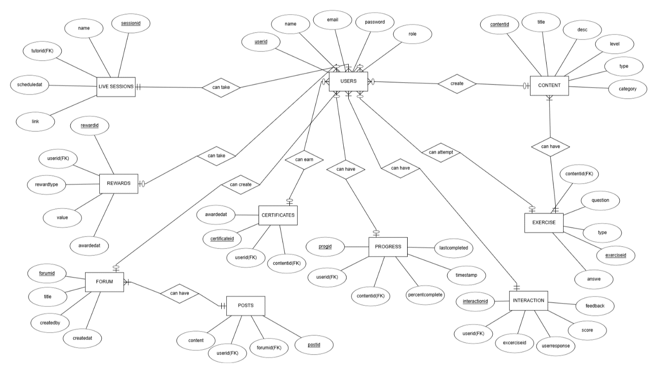

**Diagram 1**

TASK#3

# Sequence Diagrams:-

1. **Register/Login (via email or social accounts)**

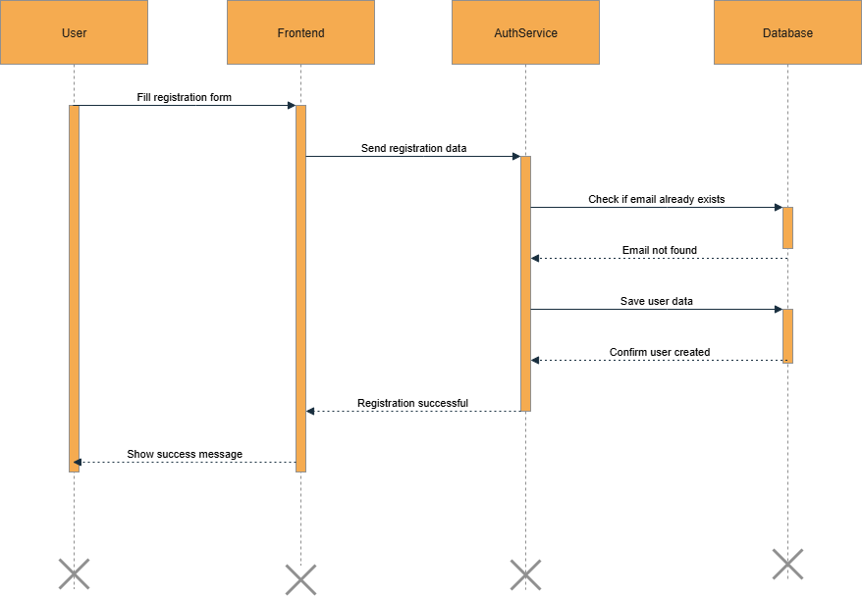

**Diagram 2**

1. **Manage User Roles (Admin, Teacher, Student)**

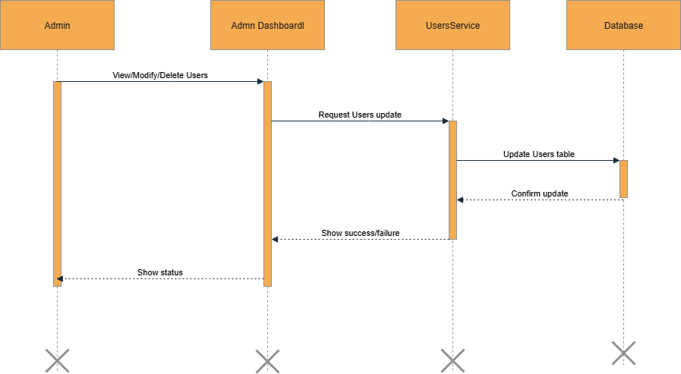

**Diagram 3**

1. **Manage Profile (update personal details, password)**

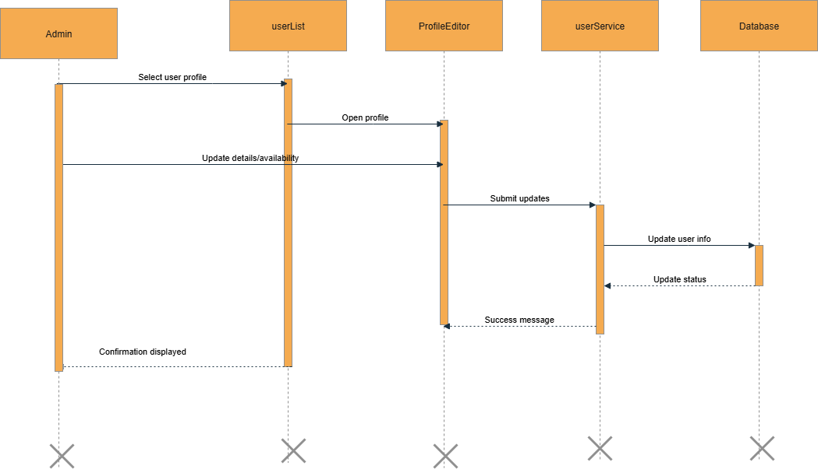

**Diagram 4**

1. **Access Learning Content (browse lessons by level and category)**

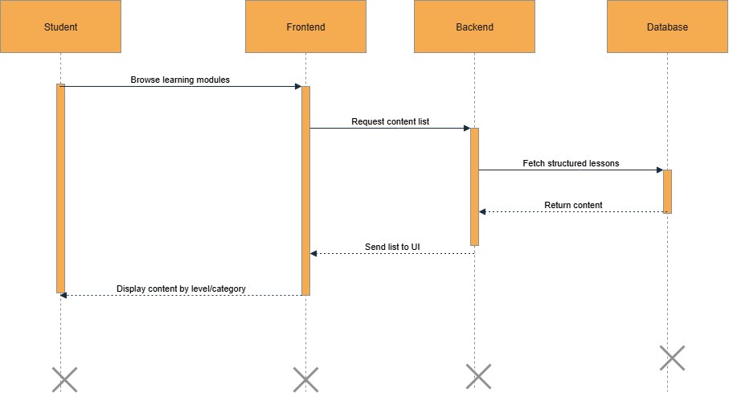

**Diagram 5**

1. **Manage Learning Content (create, update, delete content with multimedia)**

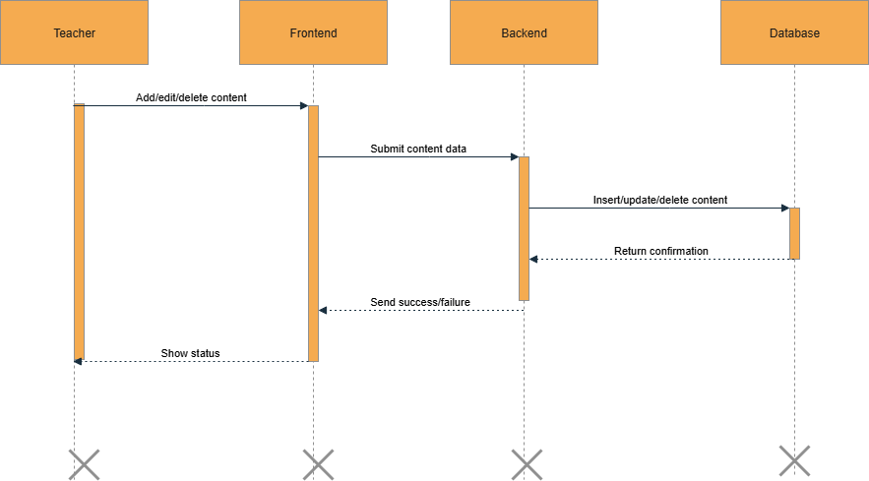

**Diagram 6**

1. **Attempt Exercises (grammar, vocabulary, speaking, writing, listening)**

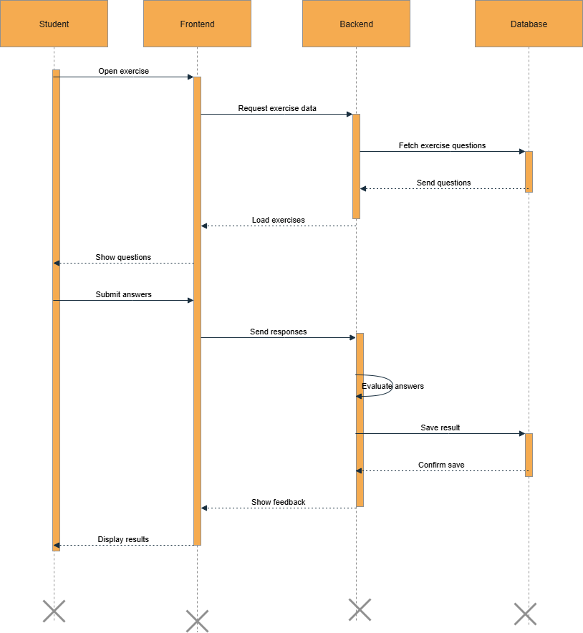

**Diagram 7**

1. **Submit Writing Tasks (get automated grammar/spell feedback)**

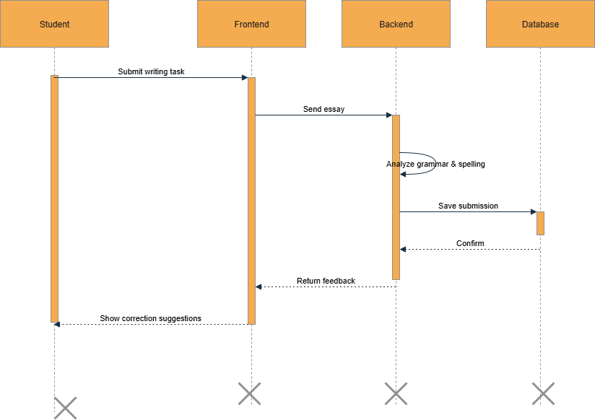

**Diagram 8**

1. **Perform Speaking Practice (speech scoring & dialogue simulation)**

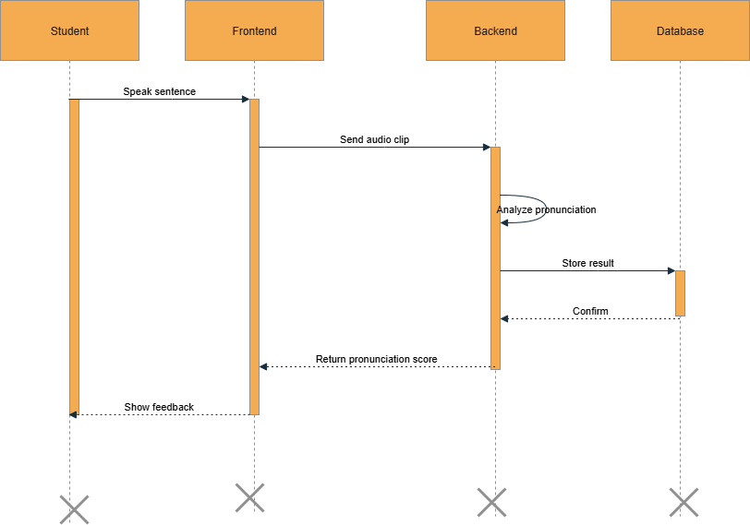

**Diagram 9**

1. **Attempt Listening Tasks (with video/audio and follow-up questions)**

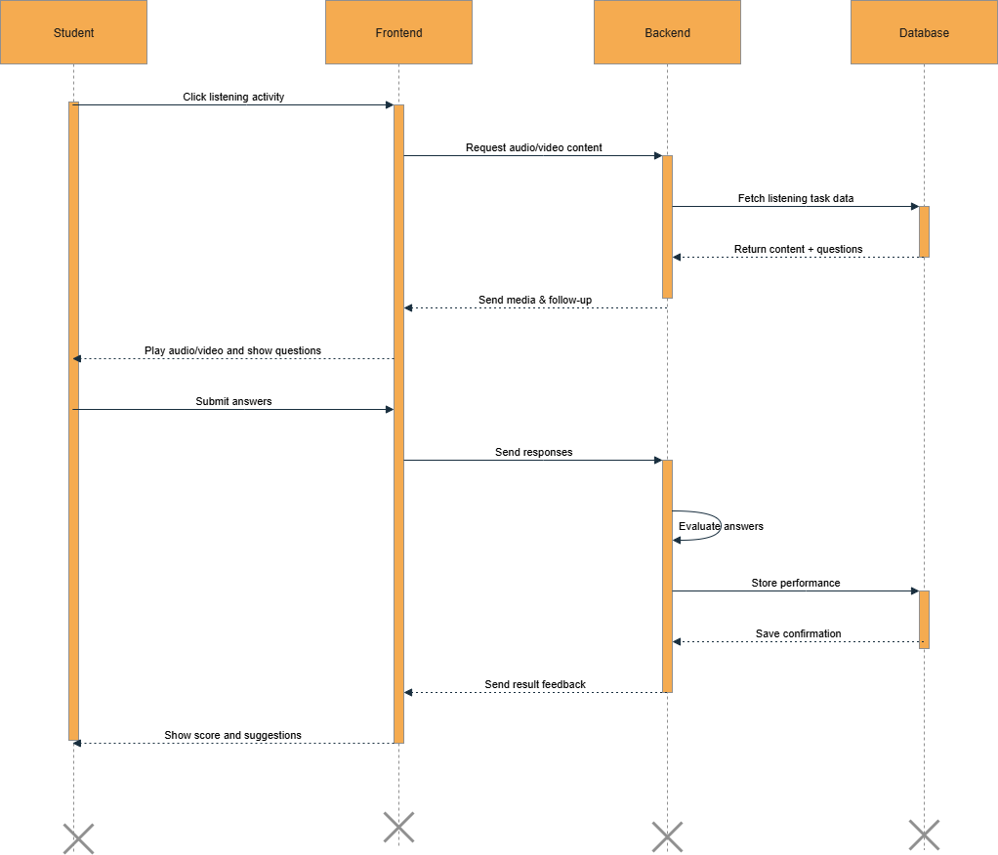

**Diagram 10**

1. **Track Progress (view dashboard, skill stats, time spent)**

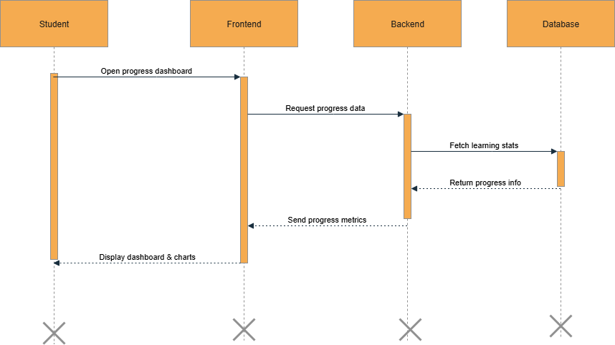

**Diagram 11**

1. **Generate Reports (view weaknesses, suggestions)**

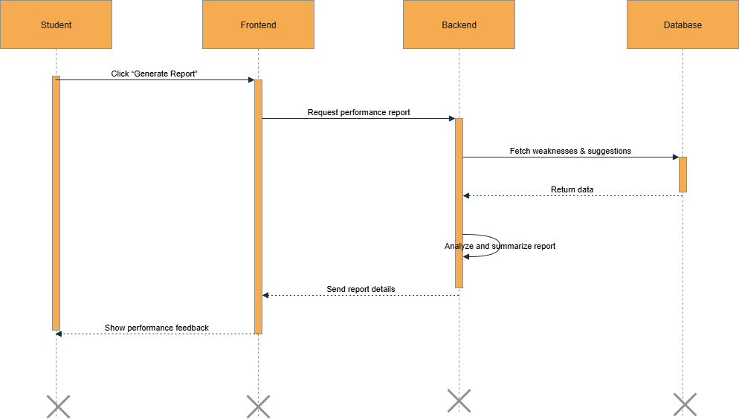

**Diagram 12**

1. **Earn Certificates (for completing lessons/courses)**

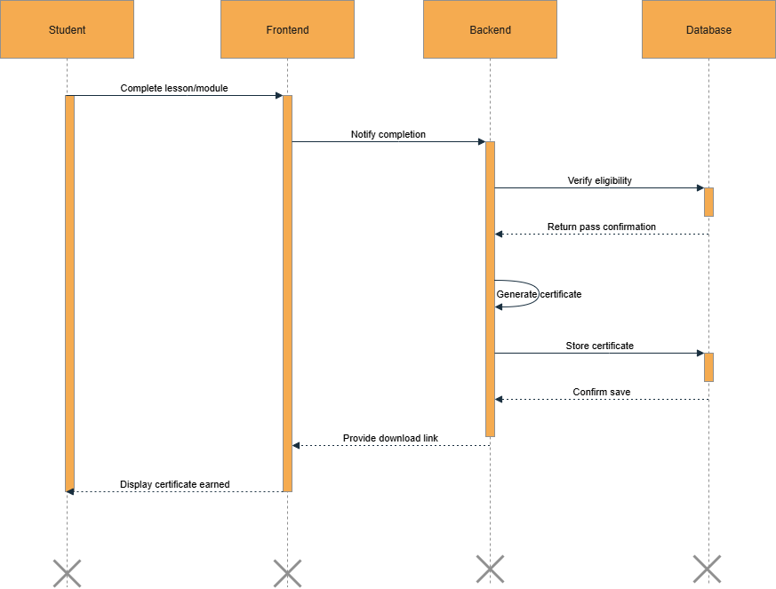

**Diagram 13**

1. **Participate in Gamification (earn points, badges, unlock milestones)**

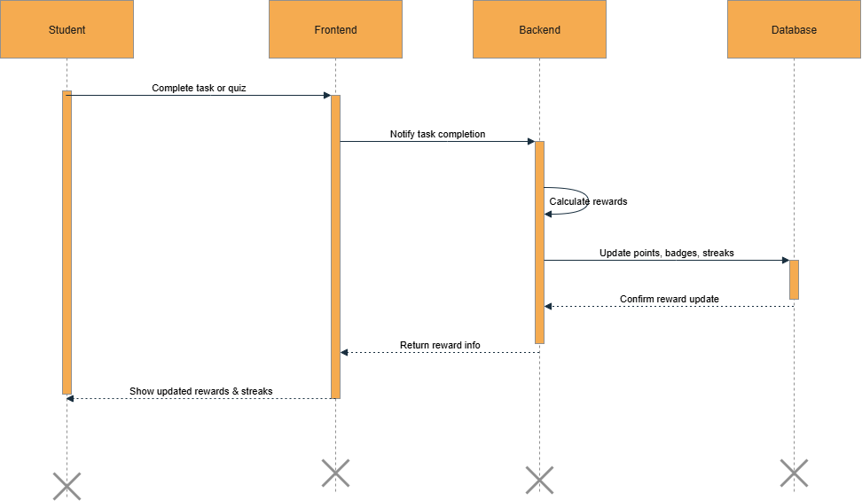

**Diagram 14**

1. **View Leaderboards (track performance against others)**

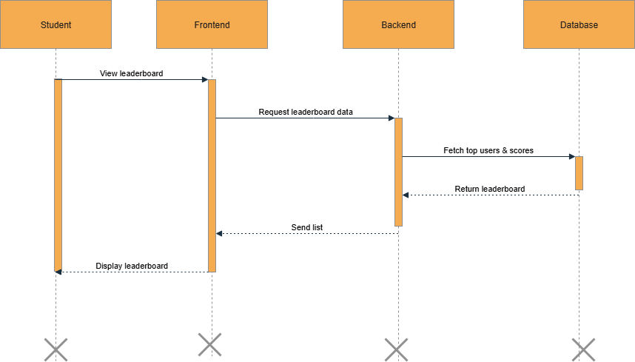

**Diagram 15**

1. **Join Live Sessions (video call with teacher or partner)**

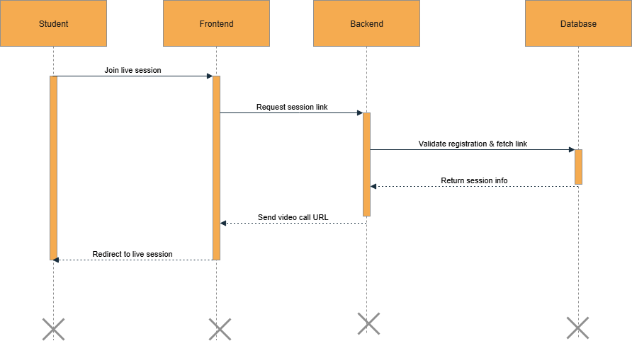

**Diagram 16**

1. **Post & Reply in Discussion Forums (grammar, topic-based)**

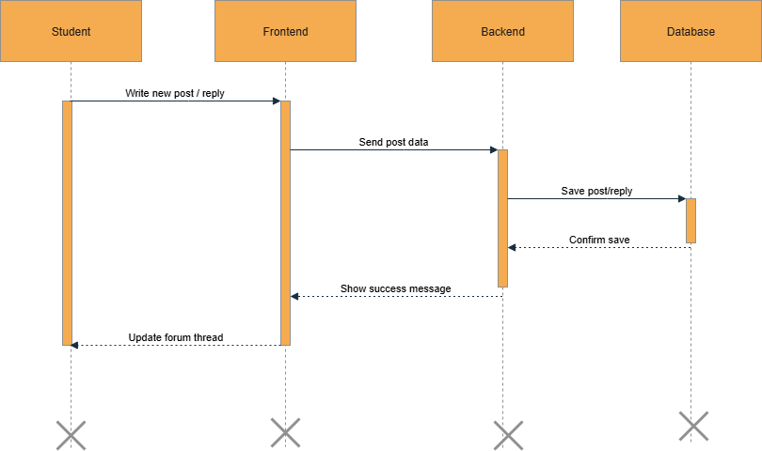

**Diagram 17**

1. **Peer-to-Peer Messaging (practice with other learners)**

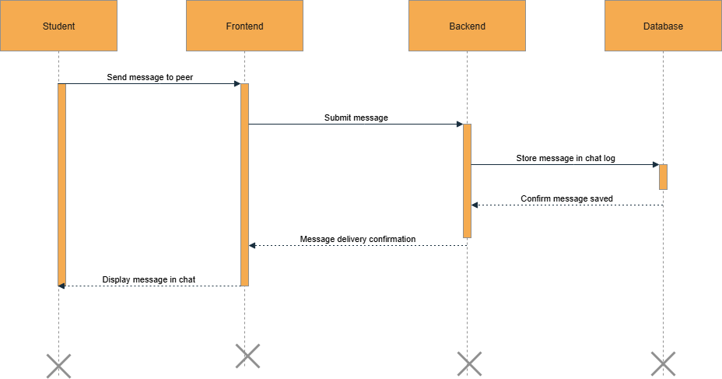

**Diagram 18**

1. **Manage Users and Analytics (Admin functions)**

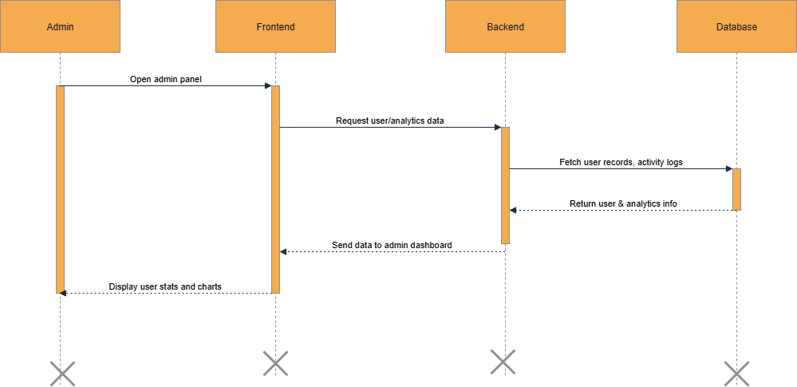

**Diagram 19**

1. **Logout**

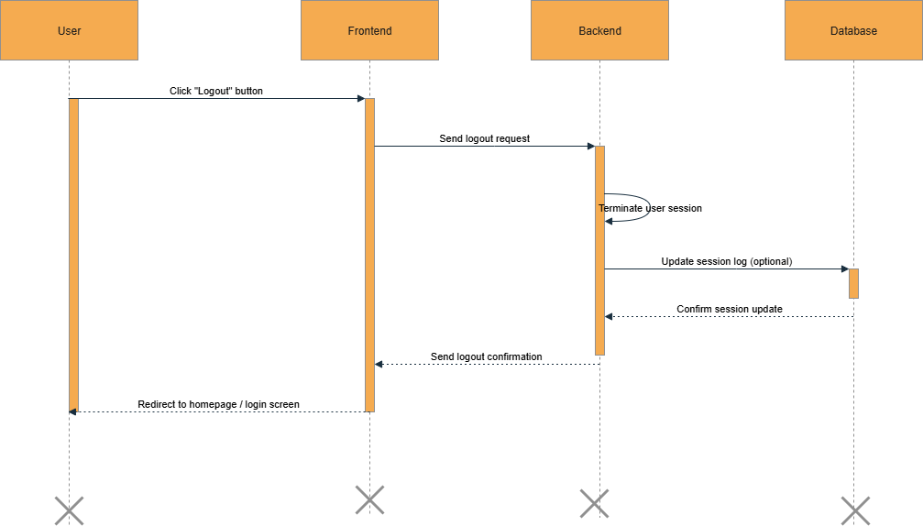

**Diagram 20**

TASK#4

# Architecture Design Diagram:-

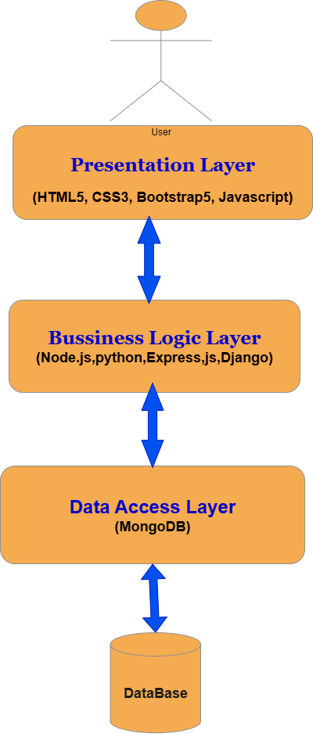

**Diagram 21**

TASK#5

# Class Diagram:-

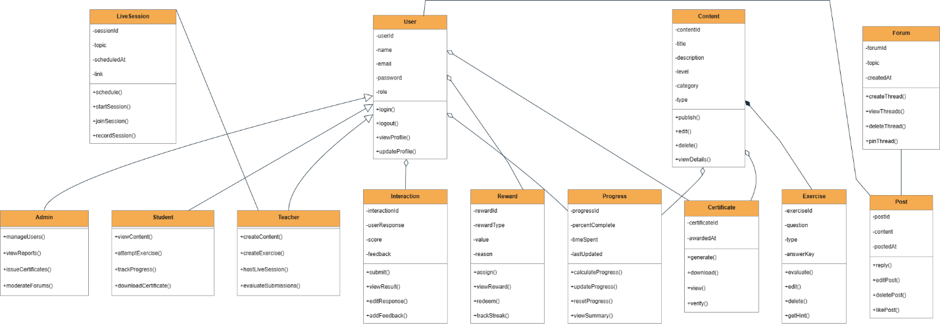

**Diagram 22**

TASK#6

# Database Design

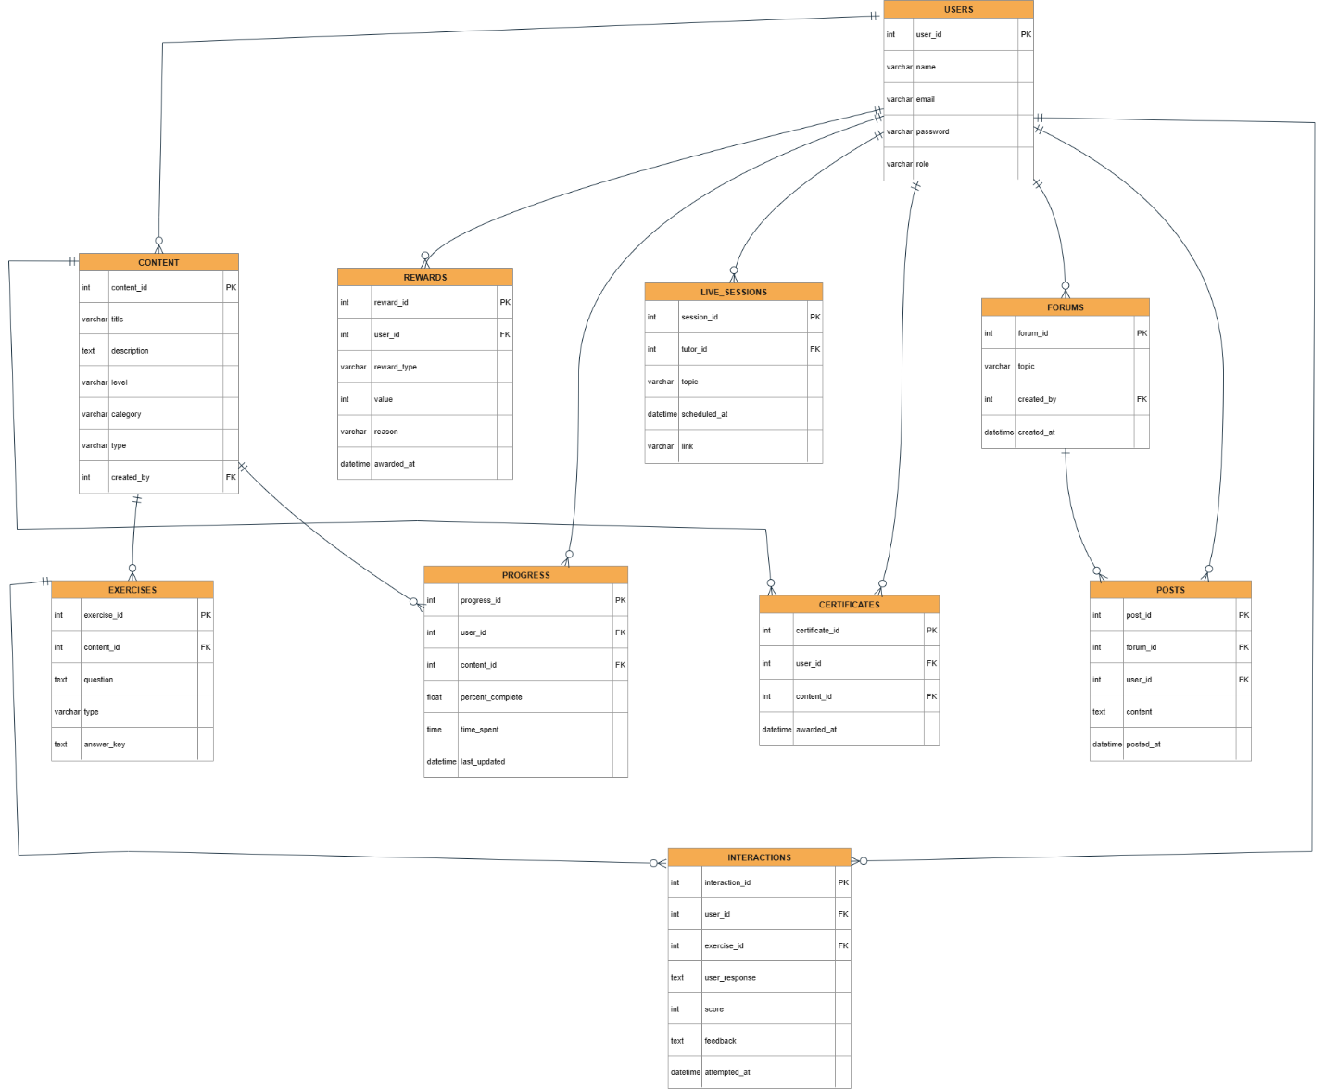

**Diagram 23**

TASK#7

# Interface Diagrams:-

1. **Application Home Page UI:-**

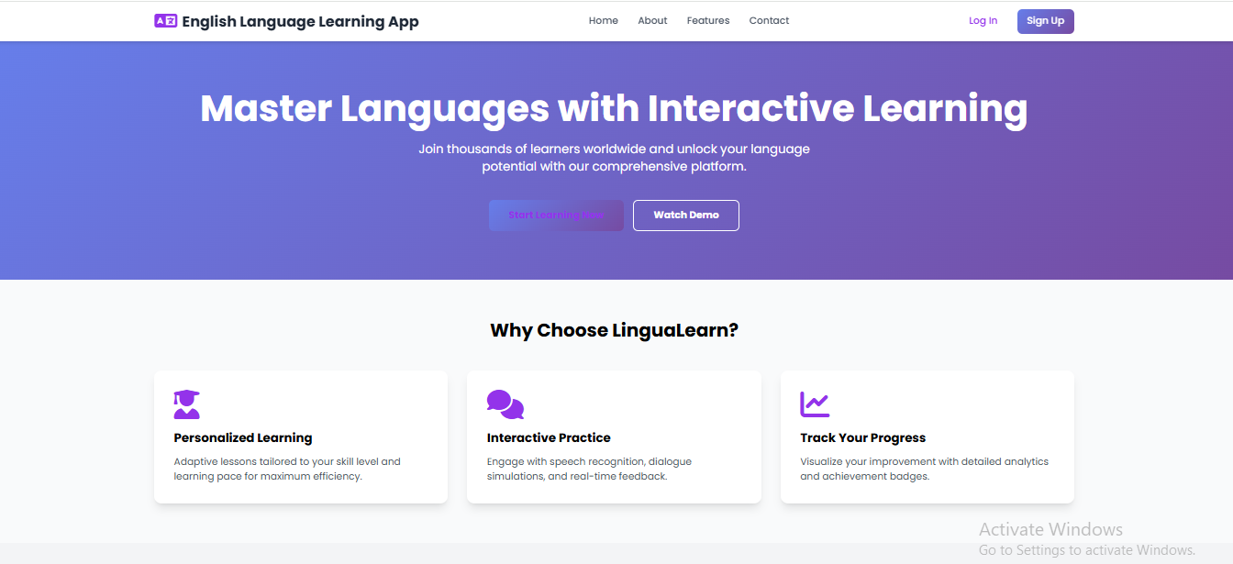

**Interface 1**

1. **Registration Page UI:-**

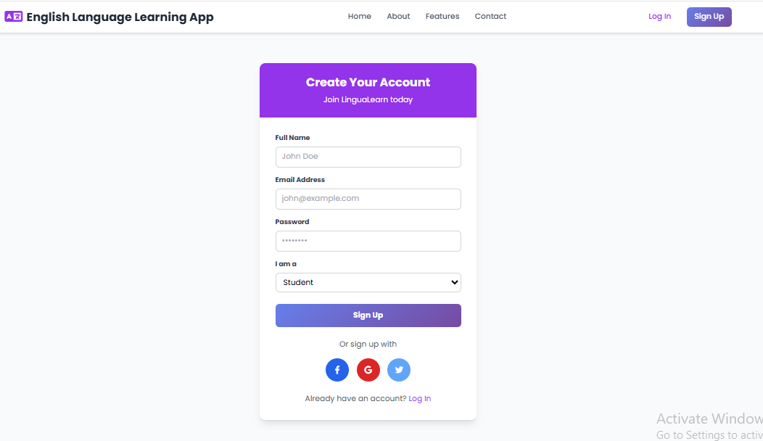

**Interface 2**

1. **Login Page UI:-**

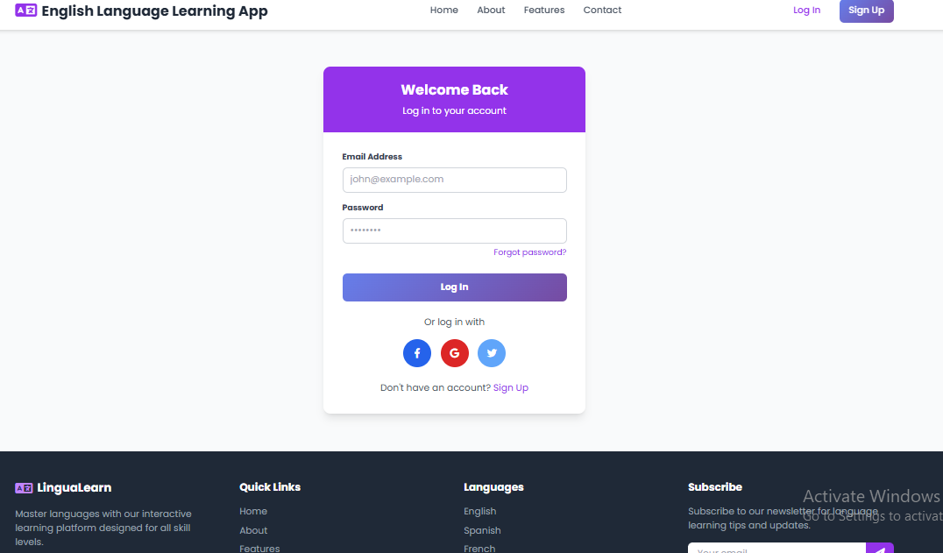

**Interface 3**

1. **User Panel UI:-**

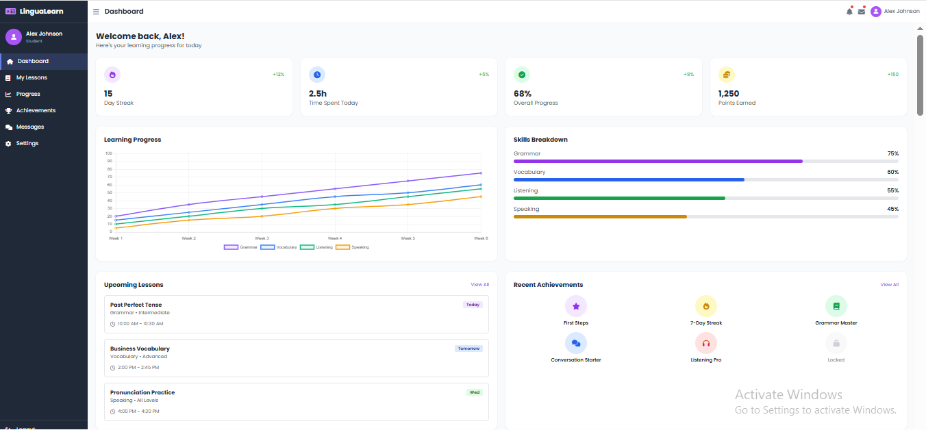

**Interface 4**

1. **AboutUs UI**

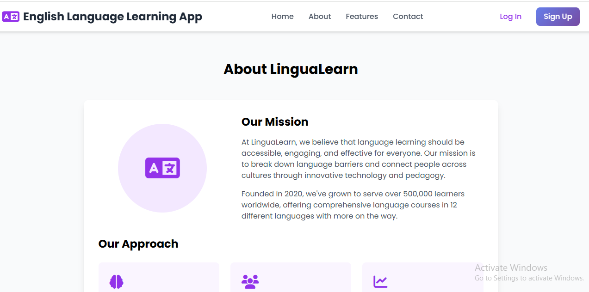

**Interface 5**

**Contact Us UI:-**

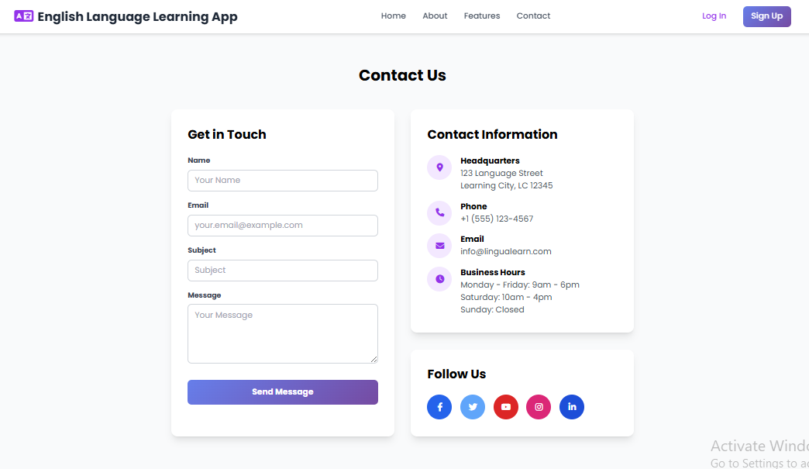

**Interface 6**

TASK#8 :

# Test Cases:-

## Test Case - TC-01 - Register/Login (via email or social accounts)

|  |  |  |  |  |  |  |  |
| --- | --- | --- | --- | --- | --- | --- | --- |
| Test Case ID | Test Case Name | Description | Test Steps | Test Data | Expected Results | Test Result | Tested By |
| TC-01 | Register/Login (via email or social accounts) | Verify the function of: register/login (via email or social accounts) | 1. Go to respective page 2. Fill required data 3. Submit and verify outcome | Valid inputs for the use case | Feature should work as intended | Pass | BC220202124 |

## Test Case - TC-02 - Manage User Roles (Admin, Teacher, Student)

|  |  |  |  |  |  |  |  |
| --- | --- | --- | --- | --- | --- | --- | --- |
| Test Case ID | Test Case Name | Description | Test Steps | Test Data | Expected Results | Test Result | Tested By |
| TC-02 | Manage User Roles (Admin, Teacher, Student) | Verify the function of: manage user roles (admin, teacher, student) | 1. Go to respective page 2. Fill required data 3. Submit and verify outcome | Valid inputs for the use case | Feature should work as intended | Pass | BC220202124 |

## Test Case - TC-03 - Manage Profile (update personal details, password)

|  |  |  |  |  |  |  |  |
| --- | --- | --- | --- | --- | --- | --- | --- |
| Test Case ID | Test Case Name | Description | Test Steps | Test Data | Expected Results | Test Result | Tested By |
| TC-03 | Manage Profile (update personal details, password) | Verify the function of: manage profile (update personal details, password) | 1. Go to respective page 2. Fill required data 3. Submit and verify outcome | Valid inputs for the use case | Feature should work as intended | Pass | BC220202124 |

## Test Case - TC-04 - Access Learning Content (browse lessons by level and category)

|  |  |  |  |  |  |  |  |
| --- | --- | --- | --- | --- | --- | --- | --- |
| Test Case ID | Test Case Name | Description | Test Steps | Test Data | Expected Results | Test Result | Tested By |
| TC-04 | Access Learning Content (browse lessons by level and category) | Verify the function of: access learning content (browse lessons by level and category) | 1. Go to respective page 2. Fill required data 3. Submit and verify outcome | Valid inputs for the use case | Feature should work as intended | Pass | BC220202124 |

## Test Case - TC-05 - Manage Learning Content (create, update, delete content with multimedia)

|  |  |  |  |  |  |  |  |
| --- | --- | --- | --- | --- | --- | --- | --- |
| Test Case ID | Test Case Name | Description | Test Steps | Test Data | Expected Results | Test Result | Tested By |
| TC-05 | Manage Learning Content (create, update, delete content with multimedia) | Verify the function of: manage learning content (create, update, delete content with multimedia) | 1. Go to respective page 2. Fill required data 3. Submit and verify outcome | Valid inputs for the use case | Feature should work as intended | Pass | BC220202124 |

## Test Case - TC-06 - Attempt Exercises (grammar, vocabulary, speaking, writing, listening)

|  |  |  |  |  |  |  |  |
| --- | --- | --- | --- | --- | --- | --- | --- |
| Test Case ID | Test Case Name | Description | Test Steps | Test Data | Expected Results | Test Result | Tested By |
| TC-06 | Attempt Exercises (grammar, vocabulary, speaking, writing, listening) | Verify the function of: attempt exercises (grammar, vocabulary, speaking, writing, listening) | 1. Go to respective page 2. Fill required data 3. Submit and verify outcome | Valid inputs for the use case | Feature should work as intended | Pass | BC220202124 |

## Test Case - TC-07 - Submit Writing Tasks (get automated grammar/spell feedback)

|  |  |  |  |  |  |  |  |
| --- | --- | --- | --- | --- | --- | --- | --- |
| Test Case ID | Test Case Name | Description | Test Steps | Test Data | Expected Results | Test Result | Tested By |
| TC-07 | Submit Writing Tasks (get automated grammar/spell feedback) | Verify the function of: submit writing tasks (get automated grammar/spell feedback) | 1. Go to respective page 2. Fill required data 3. Submit and verify outcome | Valid inputs for the use case | Feature should work as intended | Pass | BC220202124 |

## Test Case - TC-08 - Perform Speaking Practice (speech scoring & dialogue simulation)

|  |  |  |  |  |  |  |  |
| --- | --- | --- | --- | --- | --- | --- | --- |
| Test Case ID | Test Case Name | Description | Test Steps | Test Data | Expected Results | Test Result | Tested By |
| TC-08 | Perform Speaking Practice (speech scoring & dialogue simulation) | Verify the function of: perform speaking practice (speech scoring & dialogue simulation) | 1. Go to respective page 2. Fill required data 3. Submit and verify outcome | Valid inputs for the use case | Feature should work as intended | Pass | BC220202124 |

## Test Case - TC-09 - Attempt Listening Tasks (with video/audio and follow-up questions)

|  |  |  |  |  |  |  |  |
| --- | --- | --- | --- | --- | --- | --- | --- |
| Test Case ID | Test Case Name | Description | Test Steps | Test Data | Expected Results | Test Result | Tested By |
| TC-09 | Attempt Listening Tasks (with video/audio and follow-up questions) | Verify the function of: attempt listening tasks (with video/audio and follow-up questions) | 1. Go to respective page 2. Fill required data 3. Submit and verify outcome | Valid inputs for the use case | Feature should work as intended | Pass | BC220202124 |

## Test Case - TC-10 - Track Progress (view dashboard, skill stats, time spent)

|  |  |  |  |  |  |  |  |
| --- | --- | --- | --- | --- | --- | --- | --- |
| Test Case ID | Test Case Name | Description | Test Steps | Test Data | Expected Results | Test Result | Tested By |
| TC-10 | Track Progress (view dashboard, skill stats, time spent) | Verify the function of: track progress (view dashboard, skill stats, time spent) | 1. Go to respective page 2. Fill required data 3. Submit and verify outcome | Valid inputs for the use case | Feature should work as intended | Pass | BC220202124 |

## Test Case - TC-11 - Generate Reports (view weaknesses, suggestions)

|  |  |  |  |  |  |  |  |
| --- | --- | --- | --- | --- | --- | --- | --- |
| Test Case ID | Test Case Name | Description | Test Steps | Test Data | Expected Results | Test Result | Tested By |
| TC-11 | Generate Reports (view weaknesses, suggestions) | Verify the function of: generate reports (view weaknesses, suggestions) | 1. Go to respective page 2. Fill required data 3. Submit and verify outcome | Valid inputs for the use case | Feature should work as intended | Pass | BC220202124 |

## Test Case - TC-12 - Earn Certificates (for completing lessons/courses)

|  |  |  |  |  |  |  |  |
| --- | --- | --- | --- | --- | --- | --- | --- |
| Test Case ID | Test Case Name | Description | Test Steps | Test Data | Expected Results | Test Result | Tested By |
| TC-12 | Earn Certificates (for completing lessons/courses) | Verify the function of: earn certificates (for completing lessons/courses) | 1. Go to respective page 2. Fill required data 3. Submit and verify outcome | Valid inputs for the use case | Feature should work as intended | Pass | BC220202124 |

## Test Case - TC-13 - Participate in Gamification (earn points, badges, unlock milestones)

|  |  |  |  |  |  |  |  |
| --- | --- | --- | --- | --- | --- | --- | --- |
| Test Case ID | Test Case Name | Description | Test Steps | Test Data | Expected Results | Test Result | Tested By |
| TC-13 | Participate in Gamification (earn points, badges, unlock milestones) | Verify the function of: participate in gamification (earn points, badges, unlock milestones) | 1. Go to respective page 2. Fill required data 3. Submit and verify outcome | Valid inputs for the use case | Feature should work as intended | Pass | BC220202124 |

## Test Case - TC-14 - View Leaderboards (track performance against others)

|  |  |  |  |  |  |  |  |
| --- | --- | --- | --- | --- | --- | --- | --- |
| Test Case ID | Test Case Name | Description | Test Steps | Test Data | Expected Results | Test Result | Tested By |
| TC-14 | View Leaderboards (track performance against others) | Verify the function of: view leaderboards (track performance against others) | 1. Go to respective page 2. Fill required data 3. Submit and verify outcome | Valid inputs for the use case | Feature should work as intended | Pass | BC220202124 |

## Test Case - TC-15 - Join Live Sessions (video call with teacher or partner)

|  |  |  |  |  |  |  |  |
| --- | --- | --- | --- | --- | --- | --- | --- |
| Test Case ID | Test Case Name | Description | Test Steps | Test Data | Expected Results | Test Result | Tested By |
| TC-15 | Join Live Sessions (video call with teacher or partner) | Verify the function of: join live sessions (video call with teacher or partner) | 1. Go to respective page 2. Fill required data 3. Submit and verify outcome | Valid inputs for the use case | Feature should work as intended | Pass | BC220202124 |

## Test Case - TC-16 - Post & Reply in Discussion Forums (grammar, topic-based)

|  |  |  |  |  |  |  |  |
| --- | --- | --- | --- | --- | --- | --- | --- |
| Test Case ID | Test Case Name | Description | Test Steps | Test Data | Expected Results | Test Result | Tested By |
| TC-16 | Post & Reply in Discussion Forums (grammar, topic-based) | Verify the function of: post & reply in discussion forums (grammar, topic-based) | 1. Go to respective page 2. Fill required data 3. Submit and verify outcome | Valid inputs for the use case | Feature should work as intended | Pass | BC220202124 |

## Test Case - TC-17 - Peer-to-Peer Messaging (practice with other learners)

|  |  |  |  |  |  |  |  |
| --- | --- | --- | --- | --- | --- | --- | --- |
| Test Case ID | Test Case Name | Description | Test Steps | Test Data | Expected Results | Test Result | Tested By |
| TC-17 | Peer-to-Peer Messaging (practice with other learners) | Verify the function of: peer-to-peer messaging (practice with other learners) | 1. Go to respective page 2. Fill required data 3. Submit and verify outcome | Valid inputs for the use case | Feature should work as intended | Pass | BC220202124 |

## Test Case - TC-18 - Manage Users and Analytics (Admin functions)

|  |  |  |  |  |  |  |  |
| --- | --- | --- | --- | --- | --- | --- | --- |
| Test Case ID | Test Case Name | Description | Test Steps | Test Data | Expected Results | Test Result | Tested By |
| TC-18 | Manage Users and Analytics (Admin functions) | Verify the function of: manage users and analytics (admin functions) | 1. Go to respective page 2. Fill required data 3. Submit and verify outcome | Valid inputs for the use case | Feature should work as intended | Pass | BC220202124 |

## Test Case - TC-19 - Logout

|  |  |  |  |  |  |  |  |
| --- | --- | --- | --- | --- | --- | --- | --- |
| Test Case ID | Test Case Name | Description | Test Steps | Test Data | Expected Results | Test Result | Tested By |
| TC-19 | Logout | Verify the function of: logout | 1. Go to respective page 2. Fill required data 3. Submit and verify outcome | Valid inputs for the use case | Feature should work as intended | Pass | BC220202124 |

# 